**Azure DevOps Pipelines**

**Topics:**

1. **About Pipelines**
2. **Hands-on Create Environment**
3. **Web app deployment**

Reference:

<https://drive.google.com/file/d/1oFF6Ay0a-4j0kHSTHUo7cwQZEUSaUDFi/view?usp=drive_link>

(official Microsoft material) **Page 41 to 52**

Or you can download the above pdf by:

Google >> DevOps documentation >> download pdf

**What are the parts of a basic CD pipeline?**

* A basic CD pipeline contains **a trigger** to get the process going and at least one stage, or deployment phase.
* A **stage** is made up of jobs.
* A **job** is a series of steps that defines how to build, test, or deploy your application.

**What is a pipeline stage?**

A stage is a part of the pipeline that can run independently and be triggered by different mechanisms. A mechanism might be the success of the previous stage, a schedule, or even a manual trigger. You'll learn more about these mechanisms in the next module.

Ex: We could have a stage that builds the app and another stage that runs tests.

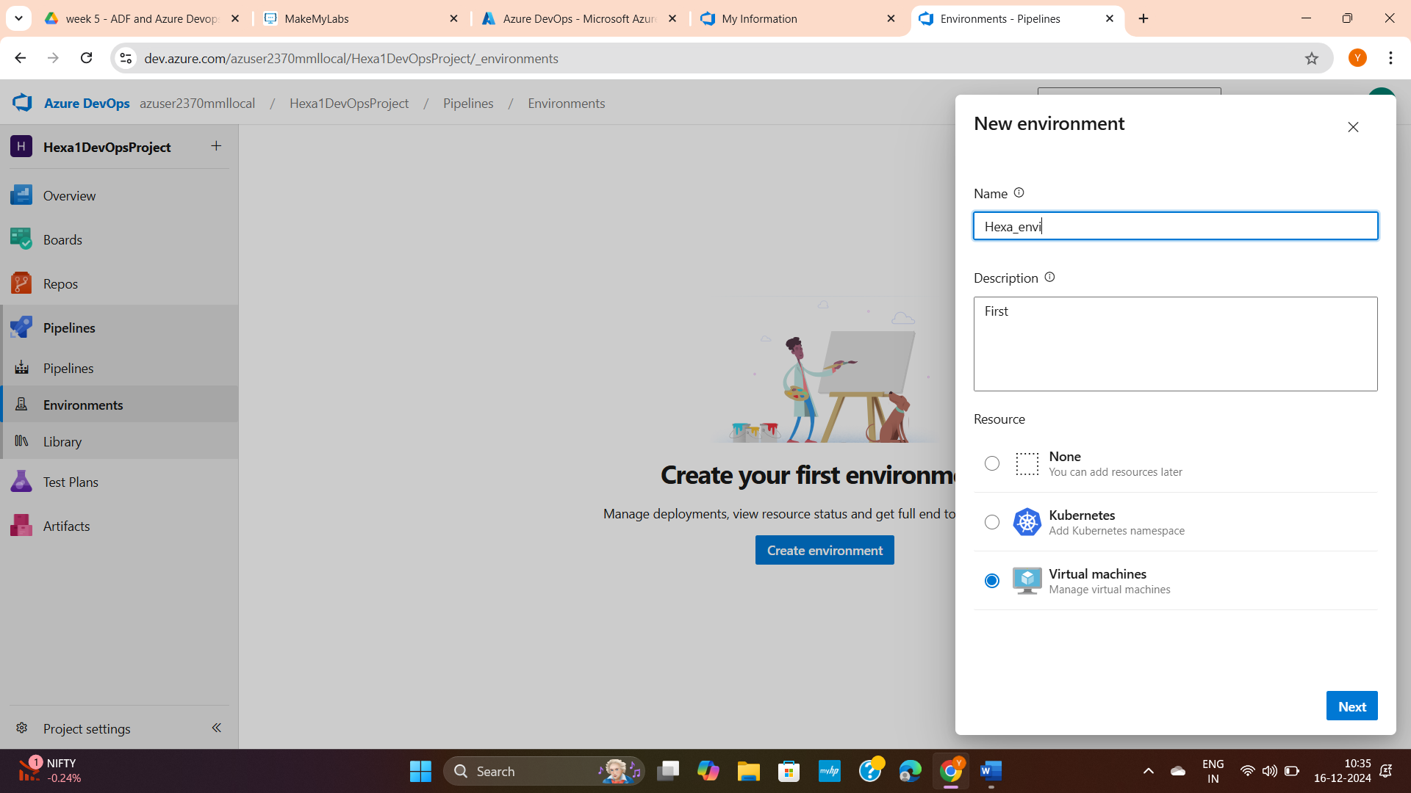

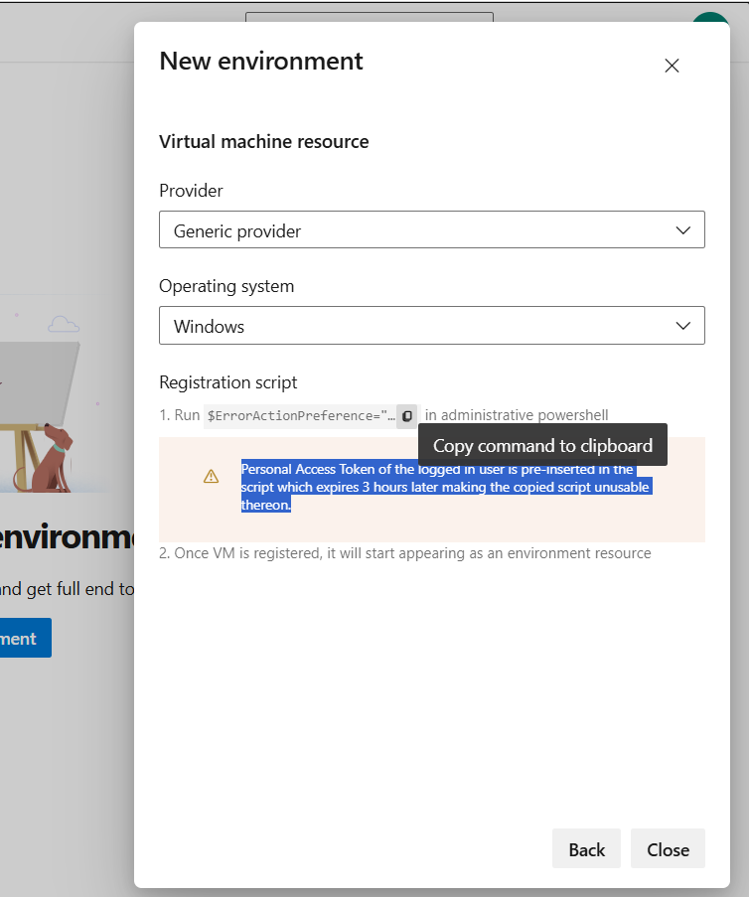

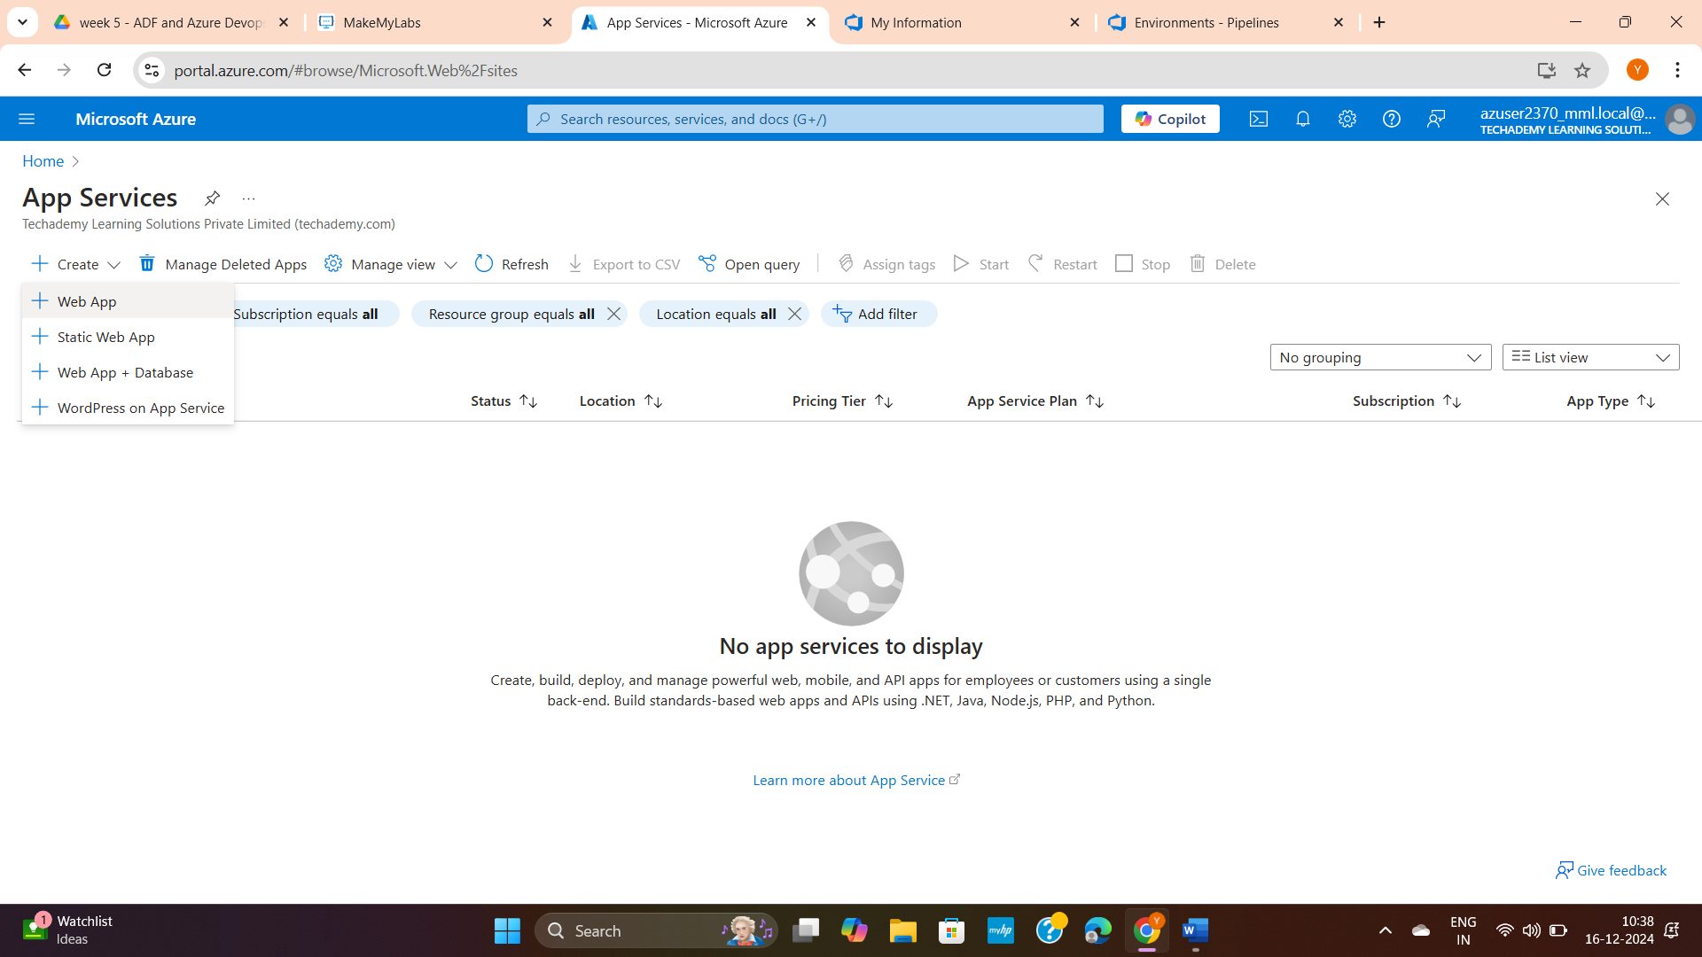

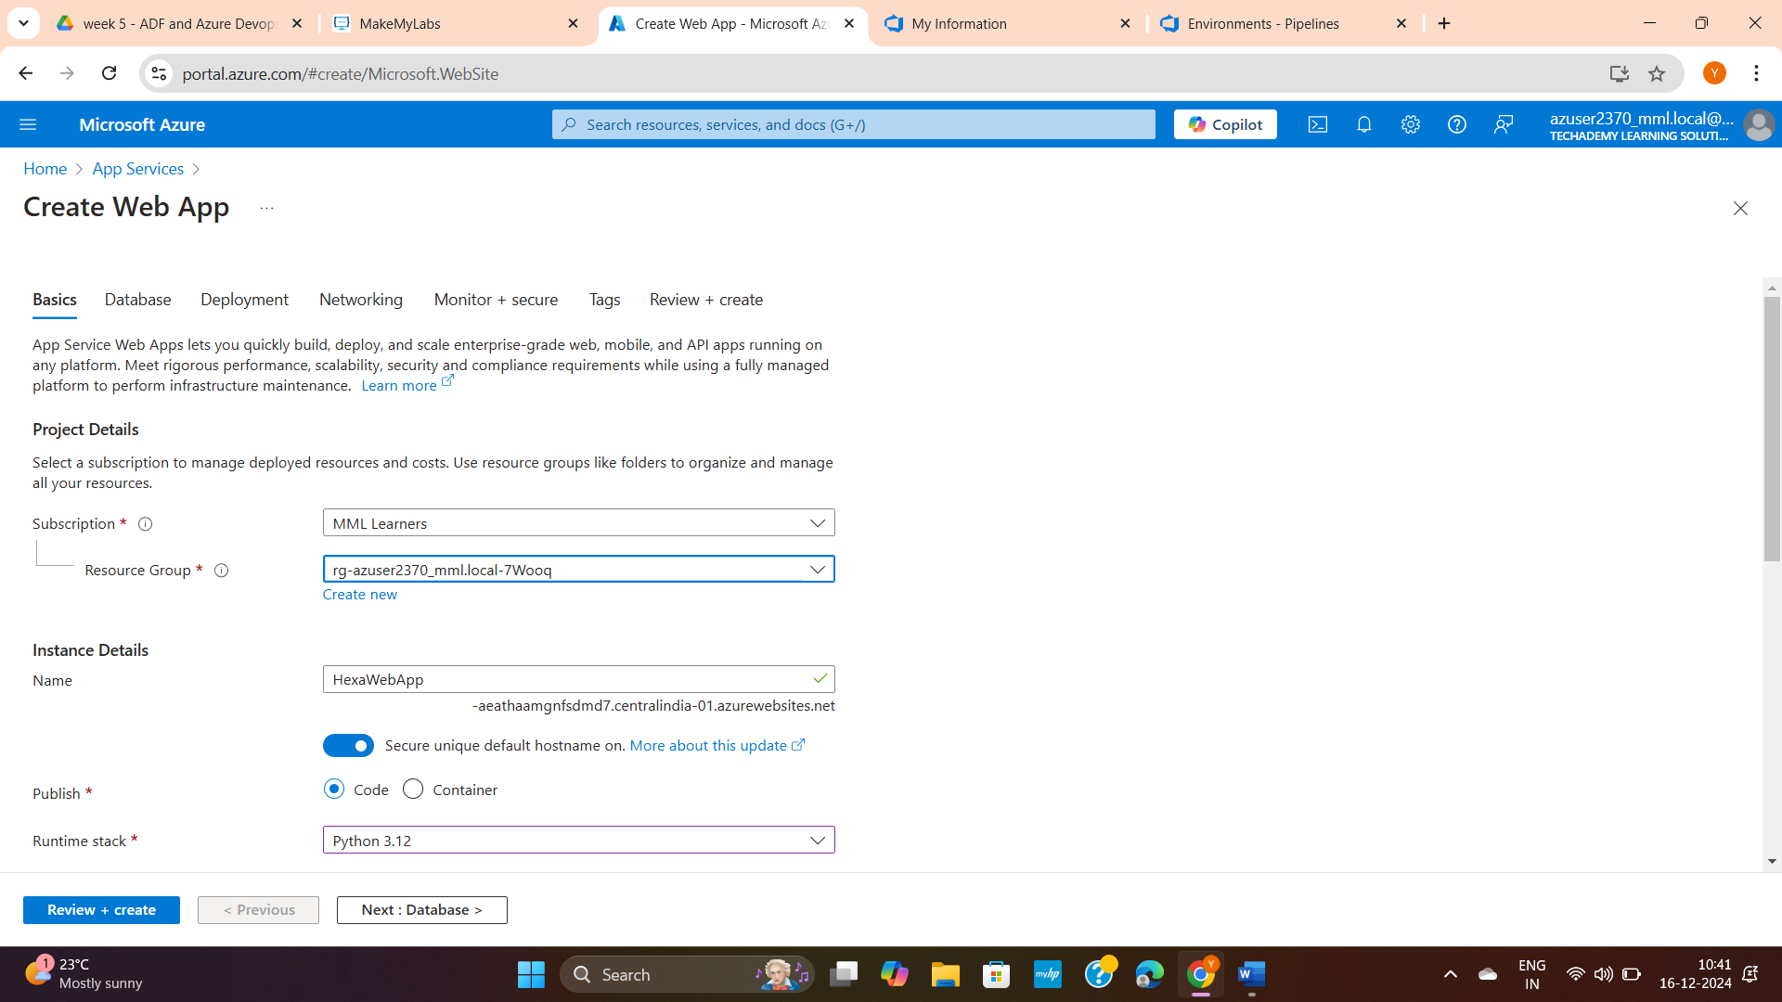

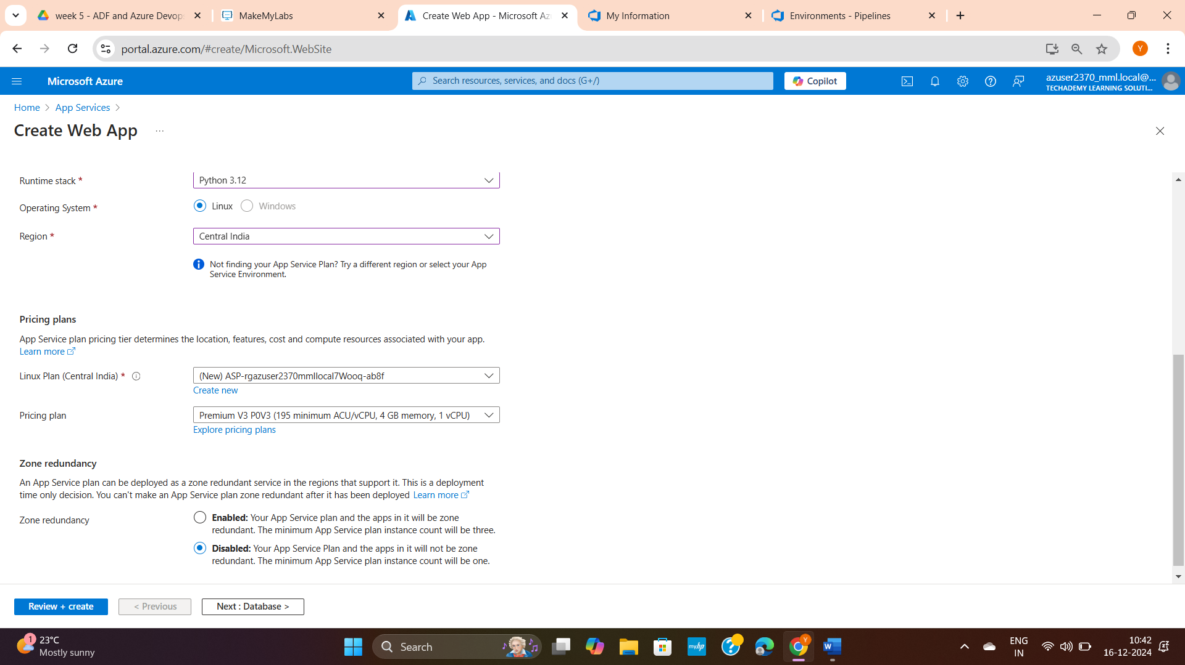

Review and create

Note:

If you want you can:

1. Create a Database – all login histories and other data will get stored in DB servers like postsql, cosmo, mysql.

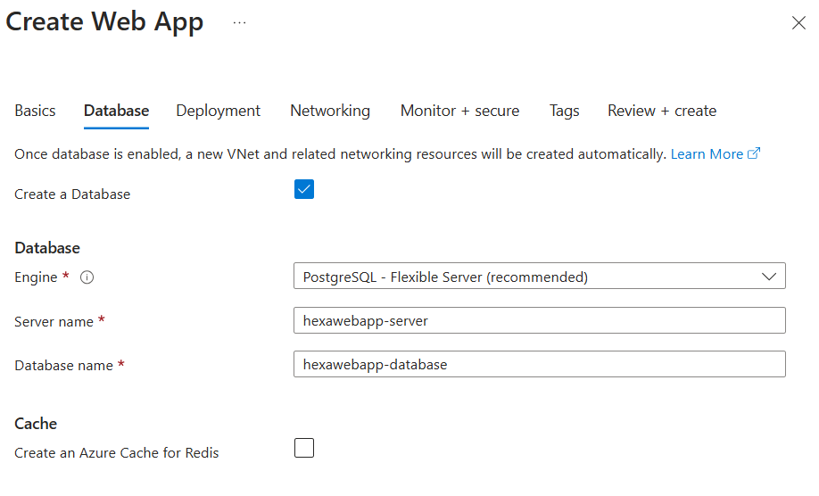

1. Set up GitHub Actions to push content to your app whenever there are code changes made to your repository.

